**INTERNSHIP REPORT**

***Introduction:***

This report explains the work I did during my internship at NULLCLASS. The goal of the internship was to build a real-time web app similar to YouTube. I worked on many features like user login, video watching, points system, subscriptions, video calling, screen sharing, and data storage using Firebase. This internship helped me turn my coding knowledge into real working experience.

***Background:***

The internship project was a complete full-stack web application. It was designed to help interns learn how real-world web apps are built and managed. I used tools like React for the frontend, Firebase for backend services, and PeerJS for video calling. The app includes important features like Watch History, Liked Videos, Subscriptions, and a video call system with screen sharing and recording.

***Learning Objective:***

* Learn how to build a complete web application from start to finish.
* Understand how to use Firebase (Auth, Firestore, and Storage).
* Add real-time features like video calls and screen sharing using PeerJS.
* Create mobile-friendly and user-friendly interfaces.
* Learn how to store and fetch user data from a database.
* I have learned to use Emailjs for triggering mail.
* Handle real project challenges like bugs, limits, and feature integration.

***Activities and Tasks:***

* Created the UI for Home, Watch Later, Liked Videos, Subscription, History, and Profile pages.
* Set up **Google login** using Firebase Authentication.
* Built a **points system** where users get 5 points for every video they watch.
* Added **subscription plans**: Free, Bronze, Silver, and Gold with daily watch time limits.
* Used Emailjs triggered emails.
* Developed a **video calling feature** with screen sharing using PeerJS.
* Added **local recording** during video calls.
* Stored and synced user data in **Firestore**.

***Skills and Competencies:***

* **Frontend**: ReactJS, JSX, CSS, Responsive Design.
* **Backend**: Firebase Firestore, Firebase Auth.
* **Authentication**: Google Sign-In.
* **Real-Time Features**: Video calling using PeerJS and WebRTC.
* **Version Control**: Git and GitHub for code tracking.
* **Debugging**: Solved errors and improved app performance.

***Feedback and Evidence:***

* commits and code pushed to GitHub.
* App successfully deployed and tested on Vercel.
* Screenshots and working video recordings as proof.
* Firebase database screenshots showing stored user data.

FIRESTORE (Data Storage):

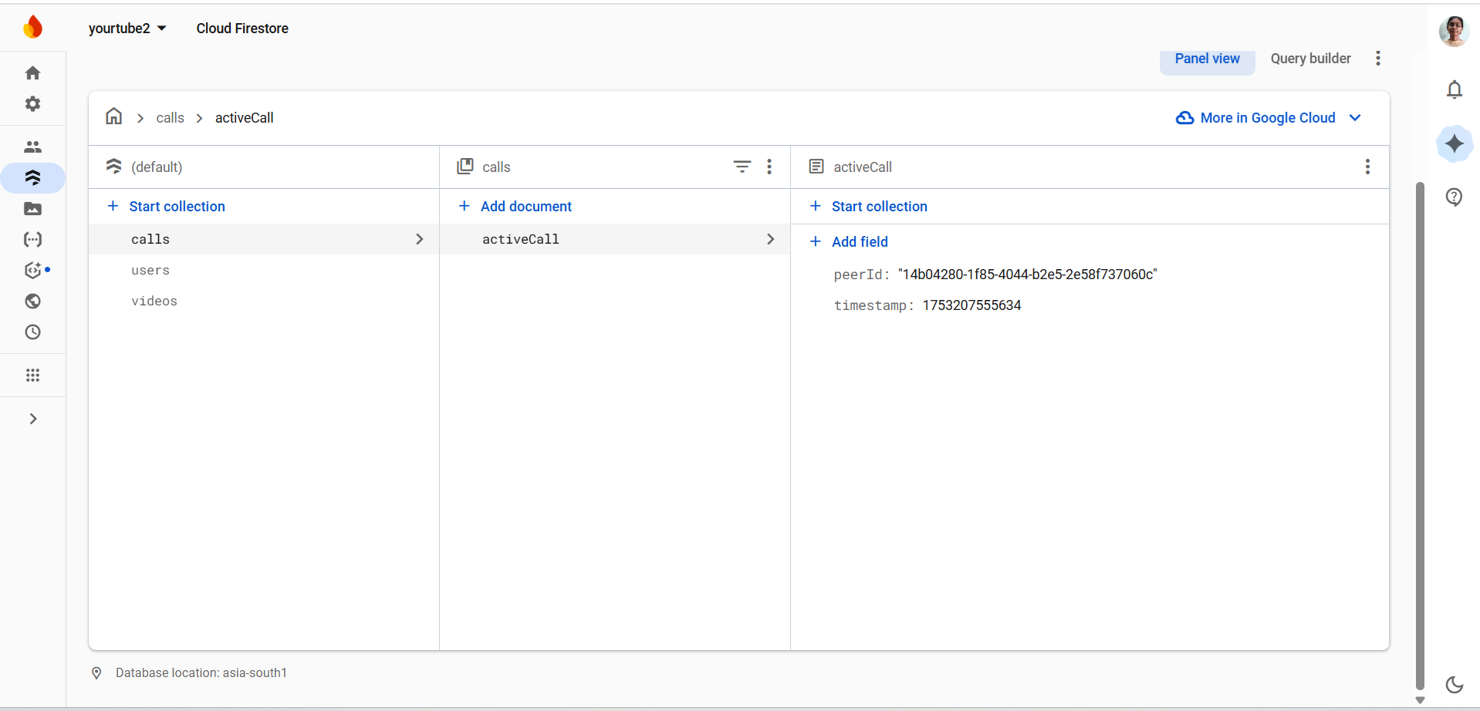

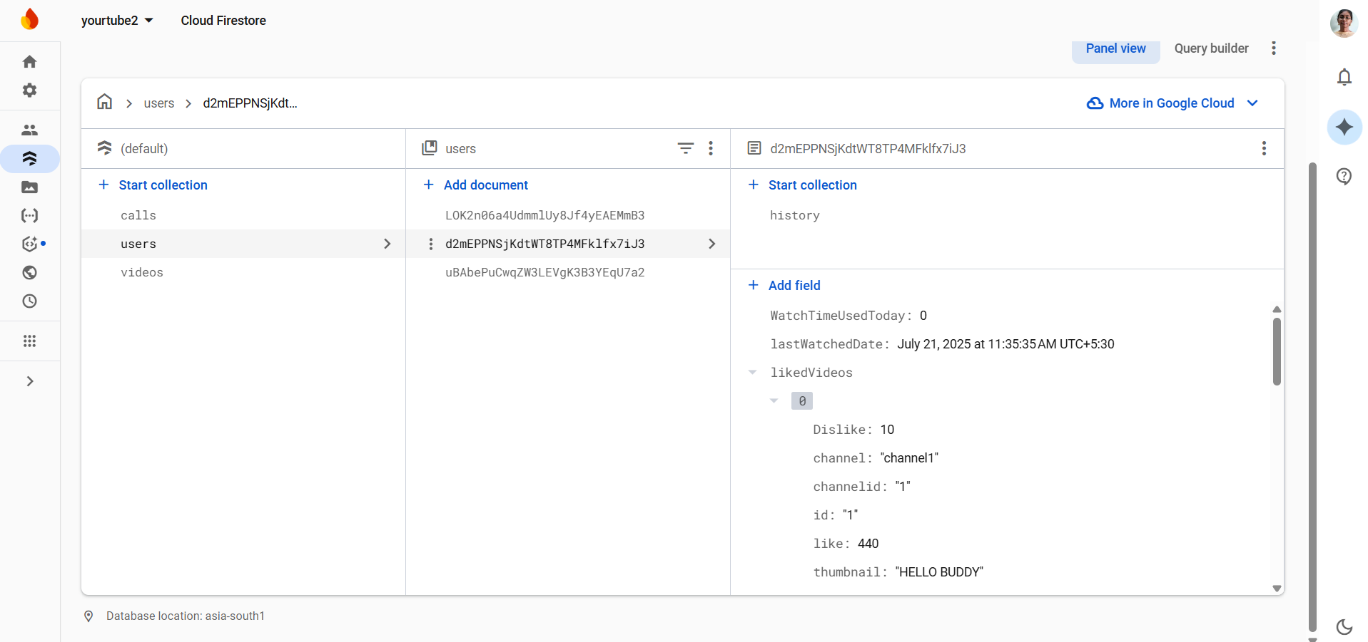

Authentication:

[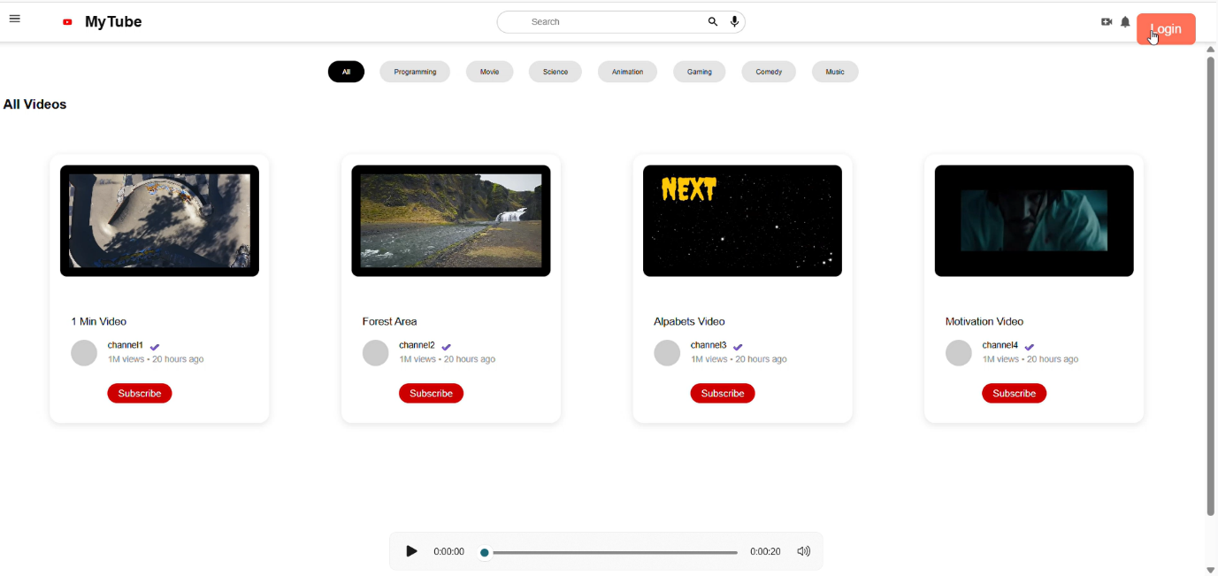](https://drive.google.com/file/d/13kiqy46bX70qRJLpkiQS3TsFg4WqUBn0/view?usp=sharing)

TASK 1:(ctrl + click to view)

[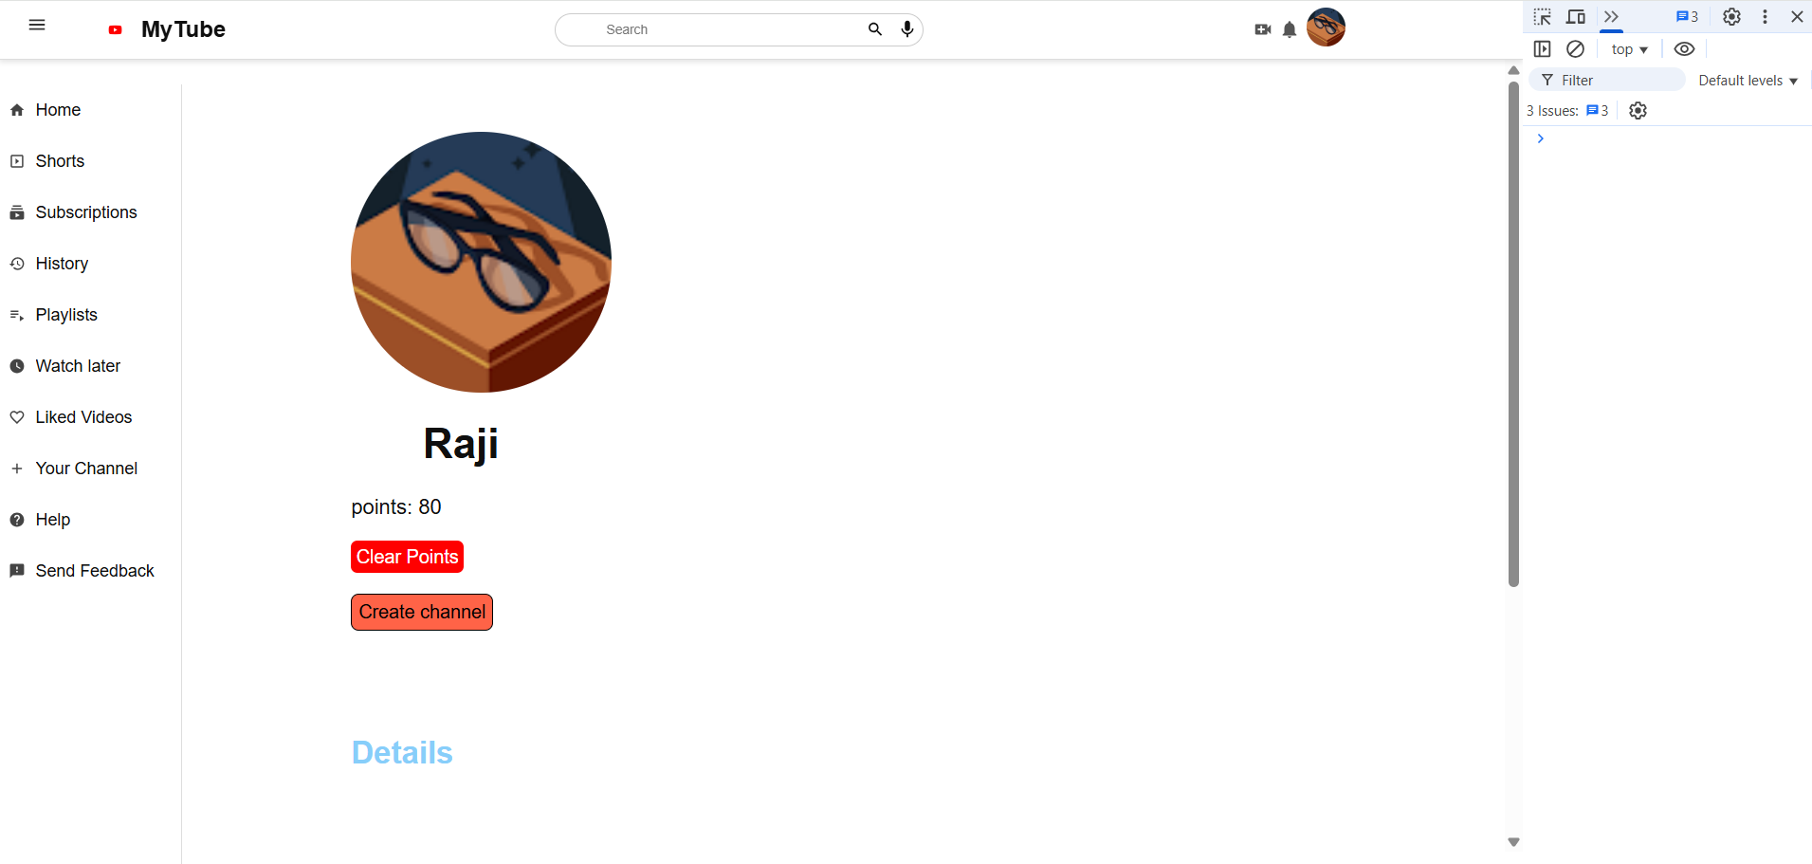](https://drive.google.com/file/d/1bdaklF9uUhYhJTOiCjM5PwFjvAA53J6Y/view?usp=drive_link)

TASK 2:

[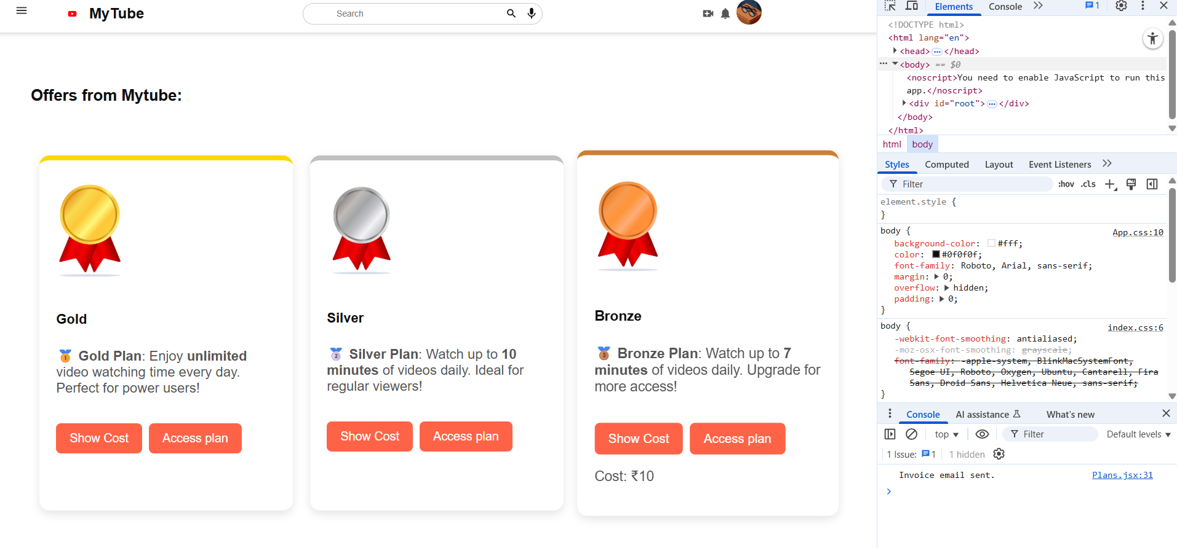](https://drive.google.com/file/d/1KQy0zVeU0__EYMbg4H1kzYc0UQUZSO7K/view?usp=sharing)

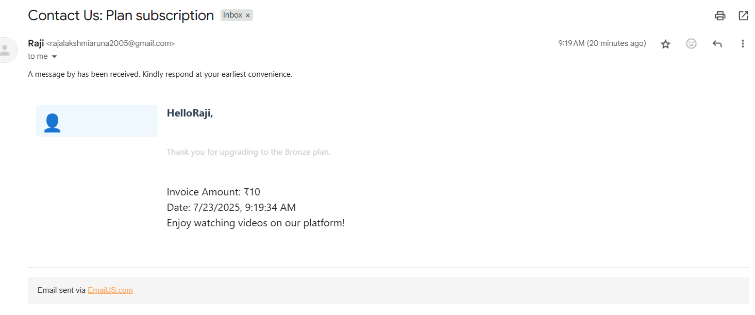

Task 3:

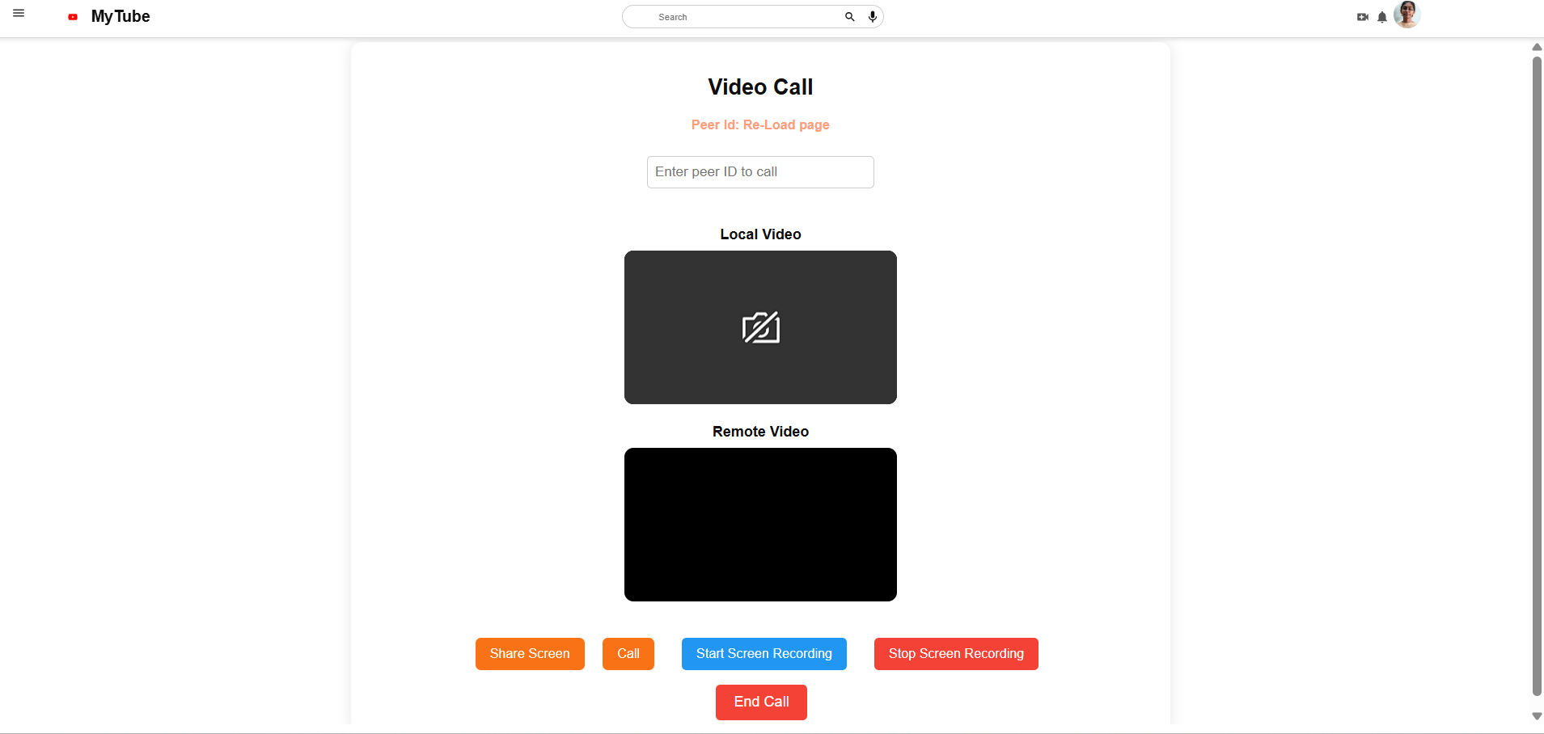

***Problems and Solutions:***

* Too many Firestore writes - Used checks and time delays to reduce writes.
* User data not showing after reload - Used onAuthStateChanged to reload data.
* Responsive layout issues -Used media queries and proper layout styling.
* Screen sharing Problem for Entire Screen – Minimized and view the screen.

***Results and Impact:***

* Successfully built a working YouTube-style app with multiple features.
* Learned how to plan and build real projects from start to finish.
* Gained experience in both frontend and backend technologies.
* Improved problem-solving and coding skills.

***Conclusion:***

This internship helped me grow as a developer. I learned how to use powerful tools like React, Firebase, and PeerJS to build a full-stack app. I also faced real challenges and found solutions, just like in a real job. This experience has prepared me for future opportunities in web development.